**How To Use HIL Board On Windows**

**Note:** The steps in this document are based on "HIL Stack - Quick Start Guide - latest release" <https://soco.intel.com/docs/DOC-1944920>﻿ .In order to more clearly describe those steps, added some pictures.

**Software Environment**: Windows 7 Enterprise 64-bit

1. Connect the HIL board and your computer, make sure you have get system administrators access.

2. Download from [here](http://mu-artifactory-builds.imu.intel.com:8081/artifactory/harts-sit-swtools-imc-mu/hcloud_utils/hcloud_hil_sw/hil_suite/) the latest HIL suite release for Windows and unpack it to e.g. **C:\HIL**

3. Install the Arduino driver:

a. Run c:\HIL\arduino\hil_arduino_install.bat

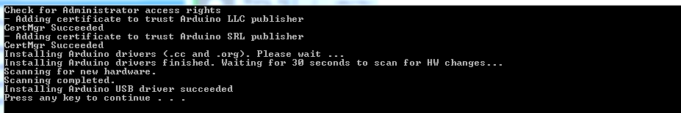

b. Update Driver Software… choose the “Browse for driver software on your computer” ,close when it finished.

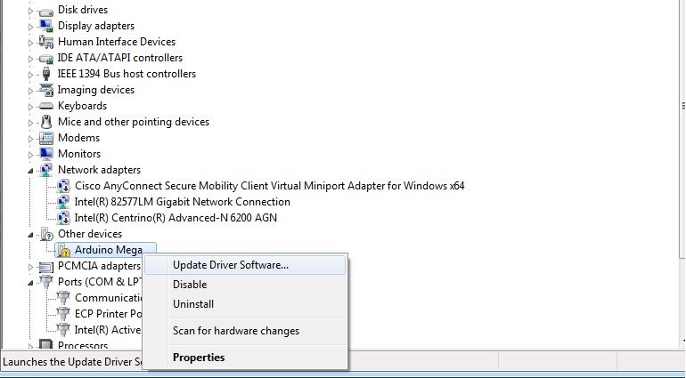

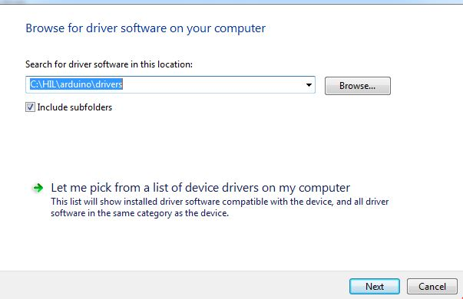

4. Flash the Arduino board:

a.Run c:\HIL\arduino\hil_arduino_flash.bat

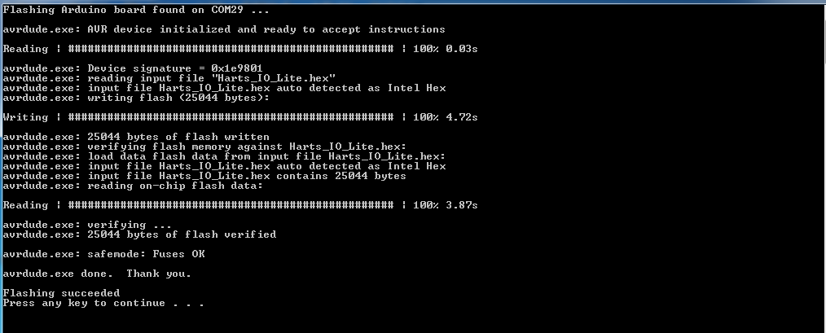

5. Install the Windows Service from an elevated console (Run as administrator):

a.Run: c:\HIL\service\install_service.cmd (optional, the server can be started manually)

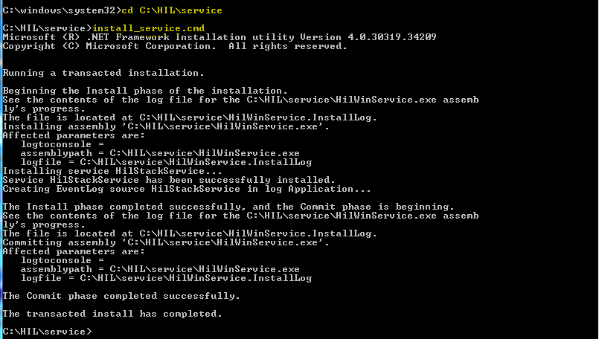

6. Start the Windows service “Hil Stack Service” from an elevated console (Run as administrator):

a.Run: net start HilStackService



7. Check that the board is OK:

a. Navigate to <http://localhost:9999>

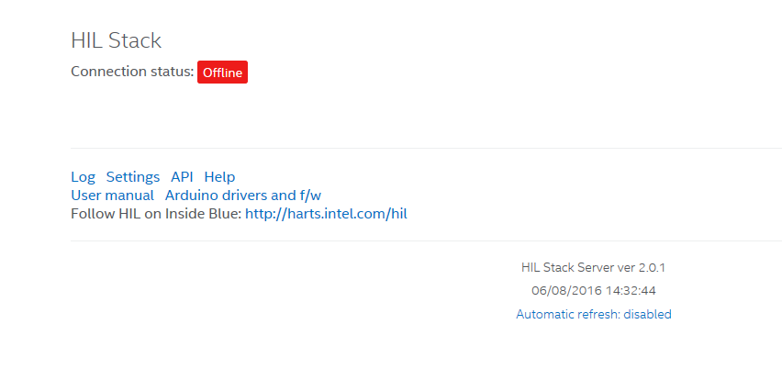

b. toggle the buttons “Connection status” and then the states

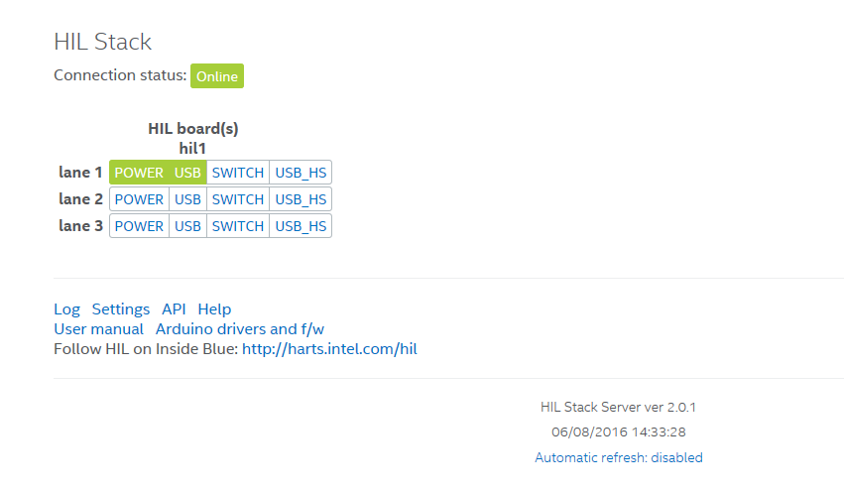

c. Close connection at the end